Bradda Niarbyl (English Champs route)
Start at Cosy Nook (tbc), Northern end of Port Erin beach and finish is above Bradda Glen cafe GR 193696.
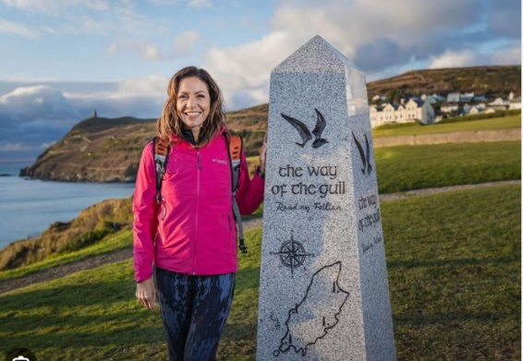
Join the Raad ny Foillan coastal footpath at the Julia Bradbury granite starter marker and continue on the flagged route to Milner Tower checkpoint. Take care on the road and give way to traffic . Any route can be taken after the flagged section.
Touch the Tower, then proceed to Bradda cairn on any of the footpaths. Proceed to Fleshwick remaining on the coastal path between Bradda and Fleshwick and taking care and giving way to road traffic.
Cross the stream next to the beach to access the ascent coastal paths to CP1 Lhiattee ny Beinnee summit cairn GR212727.
Descend Lhiattee ny Beinnee remaining on the coastal footpath to the Sloc GR216734 (short cuts are not allowed) where water may be available.
Ascend to CP2 Fishermans Stone GR223746 (40m West of Cronk Ny Arrey Laa summit cairn)
Descend to CP3 Eary Cushlin Car Park (FIRST AID) GR225763, and then follow the coastal footpath on the green lane for about 300m. Go right through a gap in the edge just before the “UNSUITABLE FOR MOTORS” gate, into Kerroodhoo plantation on a mountain bike track. Note: the only parts of the green lane and road that can be used are between CP3 and this gap into the plantation.
Descend steeply through the plantation to the kissing gate on the path to Creggan Moar, and giving way to vehicles, follow the road, going left at the T junction, and then immediately left again on the coastal footpath over the river.
Go straight ahead up “the Slabs” green lane, take the 1st footpath on the right into the field, then bear right following the flagged route across the field and over a cattle grid and down the private path [only to be used on race day, when reccying remain on the public footpath].
At GR216771 above Niarbyl Bay, re-join the coastal footpath and proceed left/South until the marshals at CP4 are reached at a position determined by best radio signal.
Continue on the coastal footpath to CP5 Gob ny Ushtey GR215757, keeping to the landward side of the path due to some steep cliff edges, and taking care if overtaking.
Ascend to CP6 Fishermans Stone GR223746 (green lane is out of bounds), then re-trace the coastal footpath outward leg via the Sloc, to CP7 Lhiattee ny Beinee GR212727, (short cuts on the ascent are not allowed), to Fleshwick, and Bradda Hill. Continue on the coastal path descending to GR188706, then turn south east to CP8 Bradda cairn GR190702. Follow any route to the Finish area above Bradda Glen Café GR193696.
Please ensure numbers are on chest and visible to marshals and video cameras at check points and finish. Any route may be used on open access land, but climbing walls, using roads/green lanes, or farmland is prohibited unless part of the Raad ny Foillan footpath and/or state above, and will result in a time penalty or disqualification, as decided by The Organiser. Although Raad ny Foillan is the 100 mile national coastal path a prior recce of the course is recommended - there are cliff edges near the path on Bradda, and between Niarbyl Bay and Gob ny Ushtey, which may require extra caution especially during periods of high wind or if overtaking is attempted. It is strongly recommended to keep to the landside of path. If using Raad ny Foillan footpath to descend (outward and return) from Cronk Ny Arrey Laa beware of deep ruts that are sometimes obscured by undergrowth on the path. Caution should be taken in Kerrowdhoo plantation as tree roots and branches present an an unavoidable hazard when descending

